**2018-2019 JPSS Proving Ground Risk Reduction Quarterly Reporting**

2019-2020 Project Information

**Principal Investigator:** Kimberly Hyde

**Team Members:** Colleen Mouw, Ryan Morse

**Organization:** Northeast Fisheries Science Center; University of Rhode Island

**Project Title**: Optimization of phytoplankton functional type algorithms for VIIRS ocean color data in the Northeast U.S. Continental Shelf Ecosystem

2019-2020 Project Summary

This project aims to optimize remote sensing phytoplankton functional type/size class (PFT/PSC) algorithms for the Northeast U.S. Continental Shelf (NES) for applications in fisheries management and ecosystem modeling. We will be collecting *in situ* optical and pigment data on six Ecosystem Monitoring cruises operated by the Northeast Fisheries Science Center. All available *in situ* data will then be used to validate the ocean color data (e.g. RRS and IOP products) from VIIRS and other sensors and evaluate several abundance and absorption based PFT/PSC algorithms.

2019-2020 Reporting Period

*Mark table, below, with an “x” corresponding to the quarter submitted*

|  |  |  |  |
| --- | --- | --- | --- |
| *CY2019 Q3: Period of Performance: 7/1/19 to 9/30/19*  *Due: October 11, 2019* | *CY 2019 Q4: 10/1/19 to 12/31/19*  *Due: January 10,2020* | *CY 2020 Q1: 1/1/20 to 3/31/20*  *Due: April 10,2020* | *CY 2020 Q2: 4/1/20 to 6/30/20*  *Due: July 10,2020* |
| Submitted 10/11/19 | Submitted 3/20/20 | Submitted 3/20/2020 |  |

2019-2020 Quarterly Dashboard



|  |  |  |  |  |
| --- | --- | --- | --- | --- |
|  | Green (Controlled) | Yellow(Caution) | Red(Critical) | Variance Summary *(Provide explanations as needed. More detail may be included in issues and risks sections as needed.)* |
| **Scope** |  |  |  |  |
| **Budget** |  |  |  | The year 1 funds that were not properly obligated have been reallocated to the year 3 budget. |
| **Schedule** |  |  |  | The 6th cruise, which is currently scheduled for May/June is at risk of being canceled because of the COVID19 outbreak. |

**Legend**

|  |  |  |  |  |  |
| --- | --- | --- | --- | --- | --- |
|  | *On Target* |  | *Deviation from plan which can be recovered* |  | *JPSS Program Science Attention needed.* |

|  |
| --- |
| 2019-2020 Quarterly Accomplishments |

**Accomplishments during this Reporting Period**

1. **Summary of Accomplishments** *(This is a high level summary of quarterly activities. This paragraph should be kept brief to half of one page or less.)*

This quarter we focused on laboratory processing and data analyse. We made progress compiling all available *in situ* data and reprocessed (using SeaDAS) the match-up satellite imagery to include additional products that will be used for validation. In addition, we acquired the recently released OC-CCI time series as well as the NOAA msl12 version of the VIIRS data. K. Turner continues to make progress with the *in situ* data validation and algorithm optimization. In addition, K. Turner presented his thesis proposal to his committee and has a timeline to graduate this summer.

Several of the team members attended the 2020 Ocean Sciences Meeting and we presented initial findings from this project.

1. **Milestones Progress** *(Provide details of the progress of each activity or milestone for this quarter as relevant. Quarterly Reports should reflect only current quarter.)*

The majority of the time spent this quarter was and laboratory processing and data analysis of the *in situ* validation data. *In situ* data compilation and satellite data processing are on track and we processed and extracted the satellite data to compare with the *in situ* data. We continue to work with WHOI on the phytoplankton imagery data and are prepared to analyze the data once available.

**Plans for the next Reporting Period:**

* Continue laboratory analyses
* Prepare of the May/June Ecosystem Monitory cruise.
* Continue data compilation of data collected on this project and additional external datasets
* If data is available from WHOI, begin the analysis of the phytoplankton imagery data
* Analyze and extract data from the NOAA msl12 and OC-CCI datasets
* Finalize the regional PFT/PSC algorithm optimization and analyze the results.
* Finalize a new NOAA Fisheries webpage on remote sensing projects at NEFSC.

**Additional Information** *(This include the following, as relevant. If particular elements are not relevant to quarterly activities, write N/A/)*

1. **User engagement:** *(In addition to PGRR meetings, this includes collaboration and support for other stakeholders such as upper level management or other agencies such as FEMA. This may include a specific event like a large fire or hurricane or a field experiment, for example.)*
2. **Conference/workshop participation:** *(Conference Name, dates, materials presented)*

Two posters were presented at the 2020 Ocean Sciences Meeting.

* Turner, K., K. Hyde, C. Mouw, R. Morse and A. Ciocheto. Regional Refinement of Phytoplankton Functional Type Algorithms for VIIRS Ocean Color Data on the Northeast U.S. Continental Shelf
* Hyde, K., A. Ciochetto, M. Forgarty, C. Mouw, R. Morse, V. Saba, and K. Turner. A 20-Year Analysis of Phytoplankton in the Northeast U.S. Continental Shelf Large Marine Ecosystem with Implications for Fisheries

During the November 2018 cruise, we encountered an unprecedented massive bloom of gelantinous phytoplankton. Samples were collected and analyzed by Jessica Carney (a student of Dr. Mouw’s) and other colleagues at URI. They identified the species as the diatom *Thalassiosira mala* Takano and presented their findings at the [Rhode Island Microbiome Seminar](https://web.uri.edu/riinbre/microbiome-symposium-2020/) in January.

1. **Project publicity:** *(news journals/articles etc.)*

Quarterly Pictures and Graphics

*JPSS Program Science requests pictures and graphics which reflect significant events or significant progress. Please include figure captions. This section should also include news worthy items. Please include pictures and graphics when experimental PGRR products benefit severe weather of environment forecasts or warnings or guidance. This section may exceed the 3 page count as needed.*

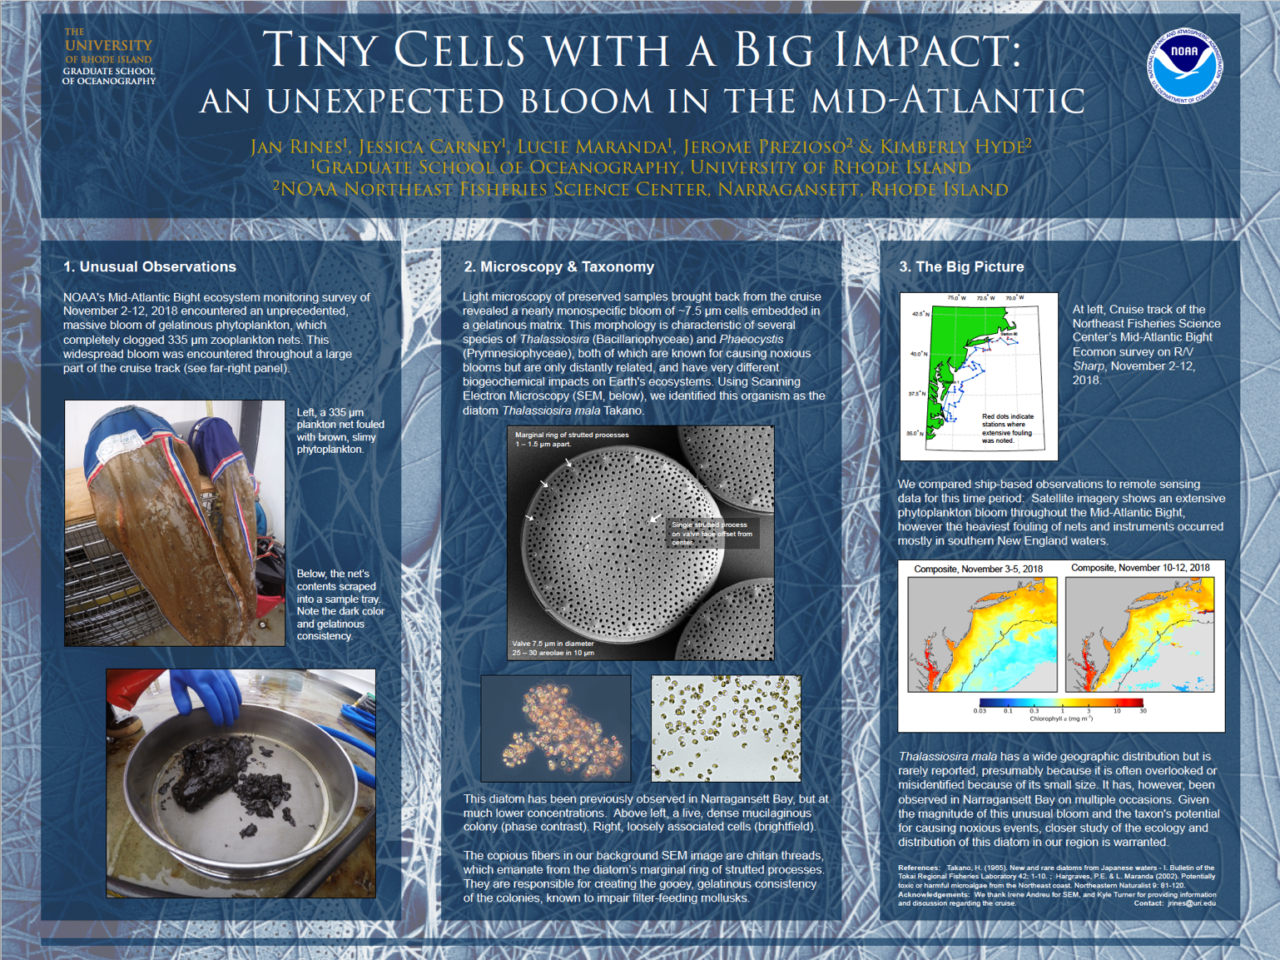

A screenshot of the poster describing the *Thalassiosira mala* bloom. For more information or permission to reproduce, please contact Jan Rines at the University of Rhode Island (jrines@uri.edu).

2019-2020 Annual Milestones with Quarterly Status Updates

*2018-2019 plan, schedule and milestones should build upon project proposals and allocated budget. This plan serves as a project management tool allowing PI’s to track and meet goals. Tasks are activities that need to be accomplished within a defined period of time. Tasks are broken down into milestones with defined start and end dates. The level of granularity is defined by individual PI. This table should be used for future quarterly reports.*

|  |  |  |  |
| --- | --- | --- | --- |
| **Milestone** | **Planned Completion Date**  *(should be part of annual plan and should not change from quarter to quarter)* | **Actual Completion** | **Status** *(not started, on track, delayed, completed …)* |
| Task 1: Field Sampling & Sample Analyses | | | |
| Field Sampling 3 | June 2019 | 6/6/2019 | Completed |
| Field Sampling 4 | August 2019 | 8/31/2019 | Completed |
| Field Sampling 5 | November 2019 | 10/31/2019 | Early |
| Field Sampling 6 | February 2020 |  | At Risk |
| Task 2: Laboratory Analyses | | | |
| Field Data Analysis 2 (URI) | May 2019 | July 2019 | Completed |
| Field Data Analysis 3 (URI) | January 2020 |  | 90% Complete |
| Field Data Analysis 4 (URI) | March 2020 |  | Slight delay |
| Field Data Analysis 5 (URI) | June 2020 |  | On Track |
| Field Data Analysis 6 (URI) | October 2020 |  | At Risk |
|  |  |  |  |
| Task 3: Data Analysis | | | |
| In situ data compilation | October 2020 |  | On Track |
| Satellite data processing | Continuous |  | On Track |
| Preliminary data analysis | January 2020 |  | 90% Complete |
| Preliminary algorithm validation | January 2020 |  | 90% Complete |
| Algorithm optimization | October 2020 |  | On Track |
| Time series analysis | May 2021 |  | On Track |
| Modeling efforts | January 2021 |  | On Track |
| Publication writing | June 2021 |  | On Track |
|  |  |  |  |
|  |  |  |  |
|  |  |  |  |

*Add rows as needed for all annual tasks and milestones. New milestones which may arise should be added at the end of the table as needed.*

|  |
| --- |
| Issues and Risks |

##### *This section should include no more than five or issues. Please separate risks from issues. Risks are the bad things that might happen. Dependencies on other projects and resources are considered risks. Issues have already occurred. High impact variances from Quarterly Dashboard can be addressed here as needed.*

##### Risk or Issue: *(State risk or issue and impact.)*

##### Issue - Due to communications issues between the program office and NEFSC, we were unaware that the year one funds received in June 2018 needed to be spent or obligated during FY’18. The result of this error was that we were not able to fund Dr. Morse for 3 months during year 1 of the project.

##### Risk - The staff from NESDIS who collect the in-water radiometry and particulate absorption samples are unable to participate in the May 2019 cruise due to other obligations.

##### Issue – The instrument we borrowed for the November 2019 cruise did not have the correct calibration files and the data are currently unreadable.

##### Risk - Changes in the availability of the NOAA ships and weather could cancel or reduce the sampling plan of the Ecosystem Monitoring cruises.

##### Risk – Delays in receiving complementary historical and coincident data from project partners NESDIS and WHOI.

##### Mitigation Plan or Course Correction: *(This includes options and actions to reduce risks/threats to project objectives. For issues, this includes plans to address impacts.)*

##### Mitigation Plan - We have spoken with Arron Layns and the PGRR program office has agreed to give us additional funds in year 3 of the project to make up for the lost funds in year 1. Dr. Morse’s work will be pushed back by approximately 6 months and will start on the project in July 2019.

##### Mitigation Plan - Dr. Mouw’s staff will use URI’s equipment to measure in-water radiometry and collect the particle absorption samples. NEFSC will purchase the additional supplies needed to collect the absorption samples and NESDIS has agreed to process the samples in their laboratory, eliminating the need to hire additional staff at URI.

##### We are working with WetLabs to correct the calibration file error

##### Mitigation Plan – We are currently schedule to participate in the May 2020 Ecosystem Monitoring cruise, but there is a chance the cruise will be postponed or canceled due to the COVID’19 outbreak. If the cruise is canceled, we will need to reevaluate our timeline and how best to proceed.

##### Mitigation Plan – We are in contact with both NESDIS and WHOI regarding the status of their data. NESDIS is currently updating their *in situ* database and hope to add historical EcoMon cruise related data this spring/summer. At WHOI, they have prioritized the August and November 2018 EcoMon cruises for quality control verification and geolocation. Historical verified IFCB data collected in the Northeast will be shared as it becomes available.

##### Status: *(If an issue or risk is closed, then it should not be reported in subsequent quarters.)*

|  |  |  |  |  |
| --- | --- | --- | --- | --- |
| **Issue/Risk** | **No Change/Open** | **Increasing** | **Decreasing** | **Closed** |
| **1** |  |  |  |  |
| **2** |  |  |  |  |
| **3** |  |  |  |  |
| **4** |  |  |  |  |
| **5** |  |  |  |  |

##### Comments: *(as needed)*